CSE 115 – Programming Language I

Fall 2020

Mid Term, Mark – 30, Section 7

Answer any **____ of the eight** questions

Upload the scanned copies of your handwritten codes/answers in the assigned portal

1. Write a code to swap two numbers without using a third/temporary variable. Hint: you cannot use more than two variables in the code.
2. Write a program that will take two arrays as input from users. Later your program needs to merge those arrays.   
   Sample input array1: 1, 3, 5, 7, 9   
   Sample input array2: 2, 4, 6, 8   
   Sample output: 1, 3, 5, 7, 9, 2, 4, 6, 8
3. Write a program in C to print the sum of the following series: 1 + 1/3 + 1/9 + 1/27 + 1/81 + .... + 1/X where, 1/X is the nth term of the series you take input from user input. Compute the summation and print the result.   
   Sample input n = 5   
   Sample output: 1.49382716
4. Write a program in C to print the second largest element in a given array and also prints the index of that element in the array. (There could be multiple occurrences of that value, so print the respective multiple indexes)   
   Sample input: 2, 9, 4, 9, 10, 8, 1   
   Output: Second largest value found: 9, occurs in index: 1, 3
5. A C program outputs the following ASCII numbers in the console, which can be decoded as a String. Now your task is to code a C program which can reverse the output numbers and can print the actual String.

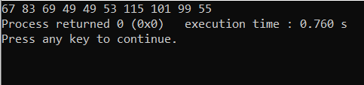

1. Write a C code to print all the prime numbers within a given range taken from user input. FYI: A prime number is that number which is only divisible by 1 and the number itself.   
   Sample input: upper range: 89 lower range: 23   
   Sample output: 23, 29, 31, 37, 41, 43, 47, 53, 59, 61, 67, 71, 73, 79, 83, 89
2. Write a program in C that can print a hollow square like the one showing in the following picture, taking the dimension from user input.

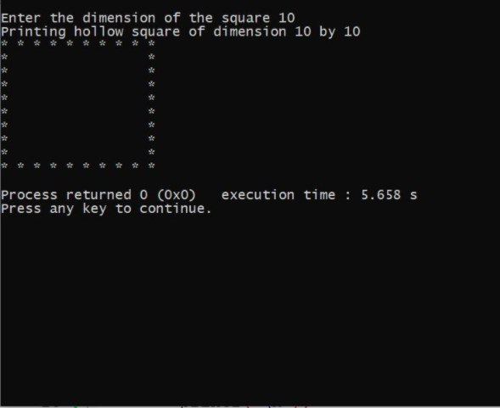

1. Code a C program which will take a String as input from user and will check if any Lowercase character exists in the String. (the string might contain numeric characters 0-9 as well) If exists, the character will be converted to Uppercase and the modified String will be displayed in output.   
   Sample input: Joe Biden 46   
   Sample Output: JOE BIDEN 46.

-------------------------------------------------------------------------------------------------------------------